Exercises- Propositional Logic

Exercise 1
Check the following properties for (’nor’), (’nand’) and (’xor’) connectives using the truth table method.
- associativity of ’’ connective: 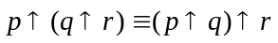;
- associativity of ’’ connective: 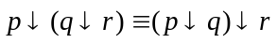;
- associativity of ’’ connective: 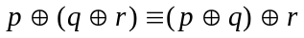;
- distribution of ’’ connective over ’’ connective:
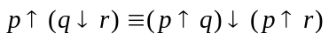;
- distribution of ’’ connective over ’’ connective:
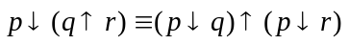;
- De Morgan’s laws for ’’ and ’’:
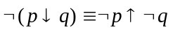 and 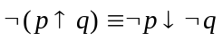;
- 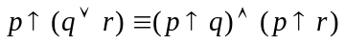 and 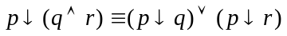.
- 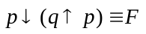 and 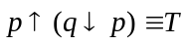;
Exercise 2
Using the truth table method decide what kind of formula (consistent, inconsistent, tautology, contingent) is 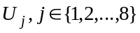. Write all the models and anti-models of .
- 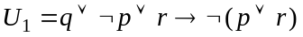; | - 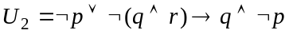;
- 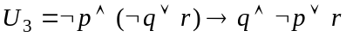; | - 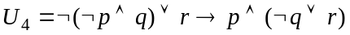;
- 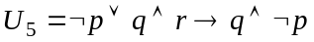; | - 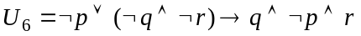;
- 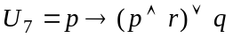; | - 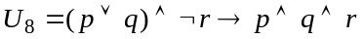.
Exercise 3
Using the truth table method, check whether the following logical consequences hold:

- 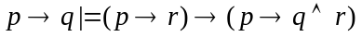; | - 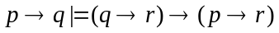;
- ; | - ;
- 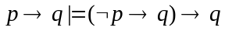; | - 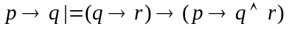;
- 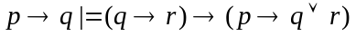; | - .

Exercise 4.
Prove that the following formulas are tautologies using the truth table method.

- the left-distribution of ’’ over ’’: ;
- the permutation of the premises law: 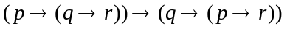;
- the reunion of the premises law: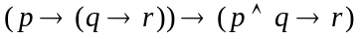;
- the separation of the premises law: 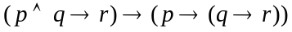;
- the left-distribution of ’’ over ’’: ;
- the left-distribution of ’’ over ’’:;
- the left-distribution of ’’ over ’’:;
- the left-distribution of ’’ over ’’:.
Exercise 5
Transform the formulas into their equivalent conjunctive and disjunctive normal forms. Using one of these forms prove that are valid formulas in propositional logic.
- ;
- ;
- 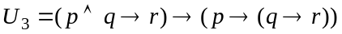;
- ;
- ;
- ;
- ;
- .
Exercise 6
Using the appropriate normal form write all the models of the following formulas:

- 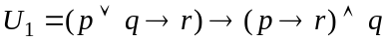;
- ;
- 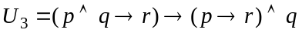;
- 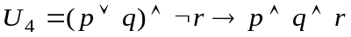;
- ;
- 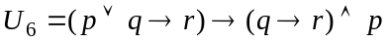;
- 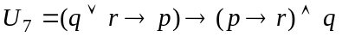;
- 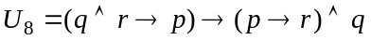.
Exercise 7
Using the appropriate normal form, prove that the following formulas are inconsistent:
- ;
- 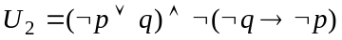;
- ;
- ;
- ;
- 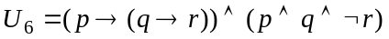;
- ;
- .
Exercise 8
Write all the anti-models of the following formulas using CNF.
- 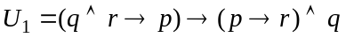;
- 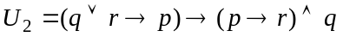;
- 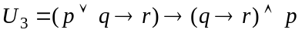;
- ;
- 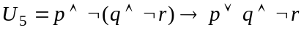;
- 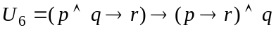;
- ;
- 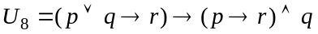.
Exercise 9
Using the definition of deduction, prove the following deductions:

- 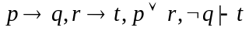; | - 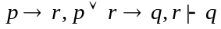;
- 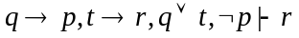; | - 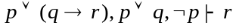;
- 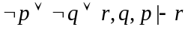; | - 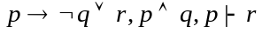;
- 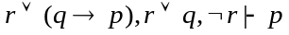; | - 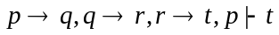.

Exercise 10
Prove the following theorems using the theorem of deduction and its reverse.

- ;
- ;
- 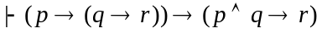;
- 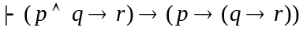;
- ;
- ;
- ;
- .

Exercise 11
Using the theorem of deduction and its reverse prove that:

- ;
- ;
- ;
- ;
- ;
- ;
- ;
- .

Exercise 12
H1: It is not sunny this afternoon and it is colder than yesterday.
H2: We will go swimming only if it is sunny.
H3: If we do not go swimming, then we will take a canoe trip.
H4: If we take a canoe trip, then we will be home by sunset.
C: We will be home by sunset.

Is C deducible from the set of hypotheses {H1,H2,H3,H4}?
If yes, build its deduction.

